1. Signatures:

The constructors are:
empty-stack : () --> Stack
push : Stack X SchemeVal --> Stack

The observers are:
top : Stack --> SchemeVal U {error: top
empty stack}
pop : Stack --> Stack U {error: pop
empty stack}
empty-stack? : Stack --> Boolean

2.

(empty-stack) = 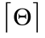
(push 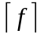 v) = 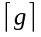
Where (top ) = v
And
(pop ) =

(empty-stack? stack) = 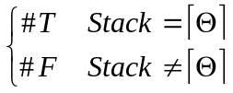

(top (push stk1 v1)) = v1
(top (empty-stack)) = error
(pop (push stk1 Var)) = stk1
(pop (empty-stack)) = error

